Software Architecture Document
E-Commerce Marketplace

Table of Content
1. Introduction 2
a. Project overview: 2
b. Purpose of the Document: 2
c. Audience: 2
d. Scope: 2
e. Document Structure: 3
f. Project State and Author: 3
2. Design and Technology Decisions 3
a. Technology Decisions 3
i. Spring Boot: 3
ii. React: 3
iii. MySQL: 3
iv. Plain Custom CSS: 4
b. Design Decisions 4
i. Component-Based Architecture: 4
ii. RESTful API Design: 4
iii. Single Page Application: 4
iv. Single Role per User: 4
v. Data Structure to Store Categories and Products: 4
vi. Single Controller for Authentication and CRUD of Users: 5
vii. Chat and Message Data Structures for Storing Messaging History between Users: 5
3. C4 Diagrams 5
a. C1 5
b. C2 6
c. C3 6
d. C4 7
4. CI/CD Diagram 8
a. Diagram 8
b. Explanation 8
i. Developers machine: 8
ii. GitLab Server: 8
iii. Pipeline Runner: 8
iv. Deployment Environment: 8
5. Conclusion 8

Version History
Version | Date | Author(s) | Changes | State
1.0 | 22/02/2024 | Serhii Sokyrko |  | Unfinished
2.0 | 29/03/2024 | Serhii Sokyrko |  | Unfinished
3.0 | 19/04/2024 | Serhii Sokyrko |  | Unfinished
4.0 | 14/05/2024 | Serhii Sokyrko | Added design constraints and included C4 | Unfinished
5.0 | 06/06/2024 | Serhii Sokyrko | Refactored CI/CD diagram and explained new decision | Unfinished

Introduction

Project overview:
    - The E-commerce Marketplace project aims to develop a robust and user-friendly online platform where users can securely buy and sell a wide range of products. The platform will facilitate seamless transactions between buyers and sellers while ensuring a smooth and efficient shopping experience.

Purpose of the Document:
    - This Software Architecture Document (SAD) serves as a comprehensive guide to the architectural design and implementation of the E-commerce Marketplace. It outlines the key design decisions, technology choices, and architectural considerations that govern the development of the platform.

Audience:
    - This document is intended for stakeholders, developers, project managers, and other members of the project team involved in the design, development, and deployment of the E-commerce Marketplace. It provides valuable insights into the overall architecture of the system, helping stakeholders understand the rationale behind design decisions and facilitating effective communication among team members.

Scope:
    - The scope of the E-commerce Marketplace project encompasses the entire software development lifecycle, from initial planning and design to implementation, testing, and deployment. The project aims to deliver a feature-rich and scalable platform that meets the needs of both buyers and sellers, providing a secure and intuitive shopping experience for all users.

Document Structure:
    - The document is structured to provide a detailed overview of the project, including its design and technology decisions and C4 diagrams. It is divided into several sections, each focusing on a specific aspect of the project. The document also includes version history to track changes and updates over time.

Project State and Author:
    - As of 14/05/2024, the project is in an unfinished state, with version 4.0 of the document being the latest iteration. The document is authored by Serhii Sokyrko, who is responsible for overseeing the development and documentation of the E-commerce Marketplace project.

Design and Technology Decisions

Technology Decisions

Spring Boot:
      - Rapid Development.
        - Spring Boot's convention-over-configuration approach reduces boilerplate code, enabling rapid application development.
      - Spring Ecosystem.
        - Leveraging the Spring ecosystem, including Spring Data, Spring Security, and Spring Cloud, provides robust solutions for various enterprise needs.
      - Dependency Management.
        - Simplified dependency management and configuration ease the integration of third-party libraries and frameworks.

React:
      - Component-Based Architecture.
        - React's component-based architecture promotes code reusability, modularity, and maintainability.
      - Virtual DOM.
        - React's virtual DOM efficiently updates the UI, resulting in better performance compared to traditional DOM manipulation.
      - Declarative Syntax.
        - React's declarative syntax simplifies UI development by describing how the UI should look based on state changes.

MySQL:
      - Relational Database.
        - MySQL is a popular open-source relational database management system known for its ACID compliance, data integrity, and robust transaction support.
      - Scalability.
        - MySQL's scalability supports large-scale applications with millions of transactions per day.
      - Community Support.
        - MySQL's large and active community provides extensive documentation, tutorials, and support resources.

Plain Custom CSS:
      - Performance Optimization.
        - Using custom plain CSS allows writing minimal CSS code tailored specifically for project needs, potentially reducing file size and improving page load times compared to using a CSS framework with pre-built styles.
      - Flexibility and Customization.
        - Custom CSS provides full control over the styling of the project without being constrained by the conventions or design patterns imposed by CSS frameworks. This allows for a more unique and customized design that aligns perfectly with the project's branding and requirements.

Design Decisions

Component-Based Architecture:
      - The system will be designed using a component-based architecture to promote modularity, reusability, and maintainability of code.
      - The system will be designed to incorporate SOLID principles and follow layered architecture design to support separation of concerns.

RESTful API Design:
      - The backend will expose RESTful APIs to facilitate communication between the frontend and backend components, enabling separation of concerns and scalability

Single Page Application:
      - The frontend will be delivered as a single-page application(SPA) using React to enhance user experience, reduce page load times, and simplify state management.

Single Role per User:
      - Simplicity and Maintainability:
        - By restricting users to a single role, the system architecture remains simpler and easier to maintain. It reduces complexity in user management and ensures clear and predictable behavior in terms of access control and permissions.
      - Security:
        - Limiting each user to a single role helps in enforcing stricter access control policies. It reduces the risk of unintended privilege escalation or unauthorized access to sensitive features or data within the system.
      - Scalability:
        - Implementing a single role per user simplifies the scalability of the system. As the user base grows, managing permissions and access control becomes more manageable, reducing the overhead associated with maintaining complex role-based.

Data Structure to Store Categories and Products:
      - Separate Tables for Product Attributes and Category Attributes:
        - By creating separate tables for these 2 entities we ensure that each product attribute will have one according attribute from category and will only contain the value of the product attribute.
        - Unloads logic of storing and retrieving products with attributes while also helps to avoid data duplications and maintain data intergrity which will allow robust scaling with growing requirements.

Single Controller for Authentication and CRUD of Users:
      - Maintability:
        - By creating a single controller class for user related operations we ensure that only this part of the application will be responsible for handling these operations which will also increase the maintability and scalability.
        - Single controller allows to maintain SRP in the code structure as far as only this component will be responsible for handling user related operations.

Chat and Message Data Structures for Storing Messaging History between Users:
      - Scalability:
        - By creating 2 separate data structures we ensure that messages can be extended to contain reactions, contain different type of data: text, videos, images, documents
        - By creating a chat data structure we ensure that the chat is specified between 2 users and with selected topic which further more allows us to keep a better control over it as of a single object which allows us to perform more specific actions which increases user experience and safety of communication.

C4 Diagrams

C1
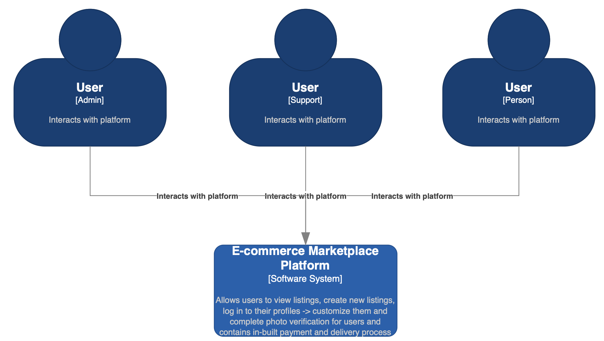

C2
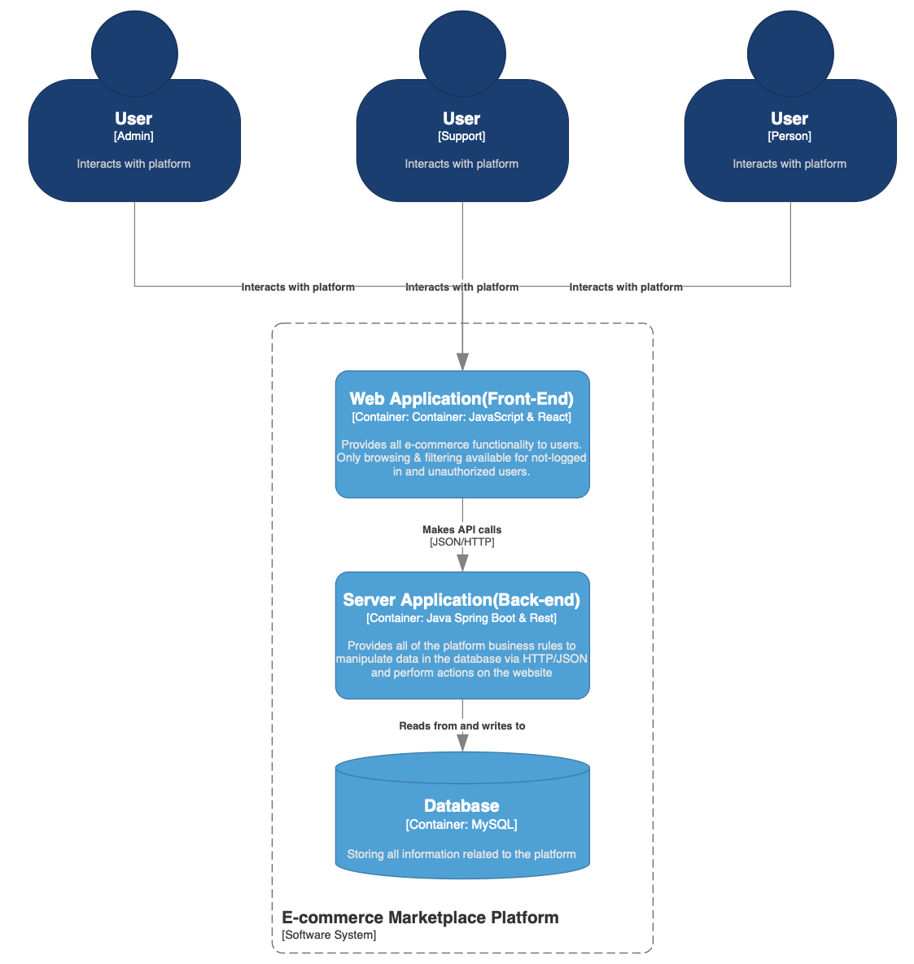

C3
Please check file attached inside SAD FOLDER

C4
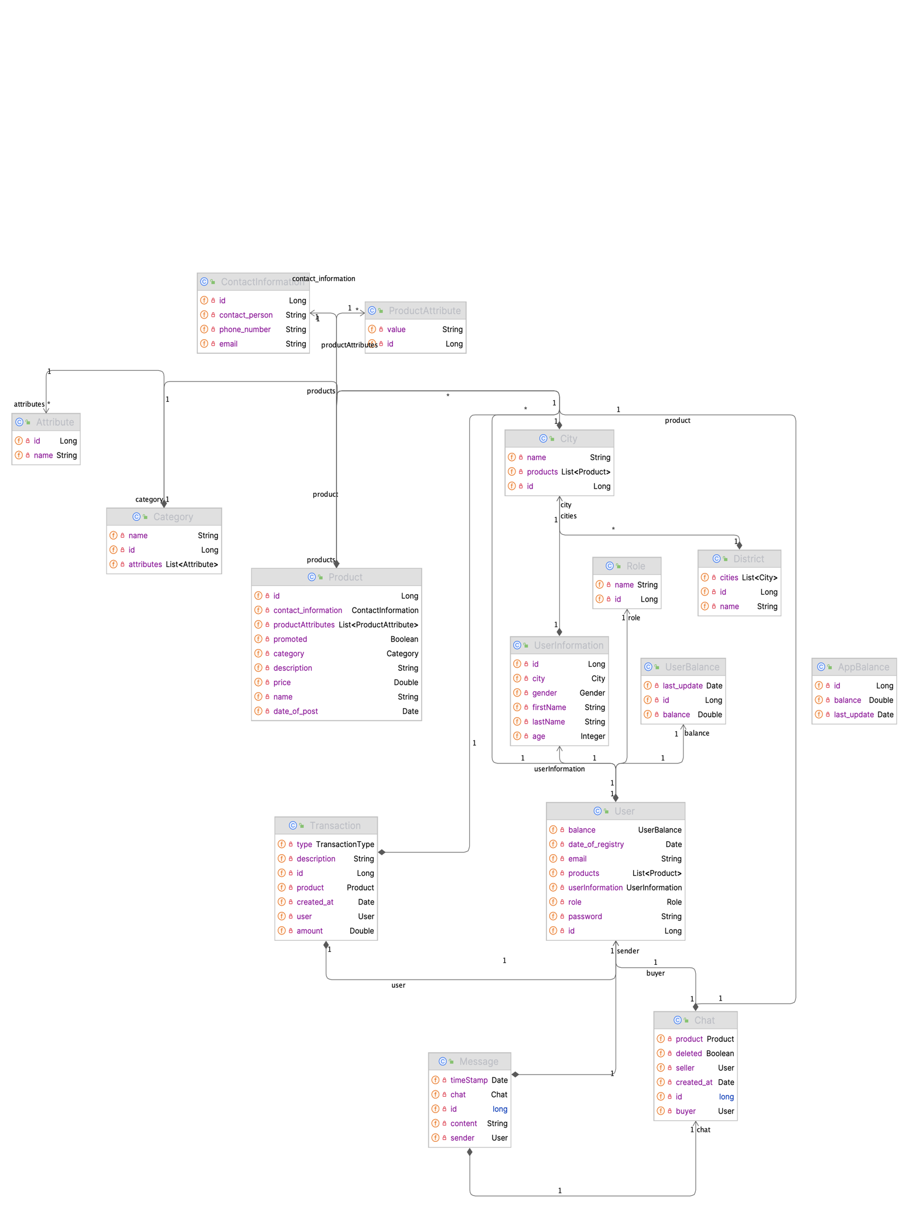

CI/CD Diagram

Diagram
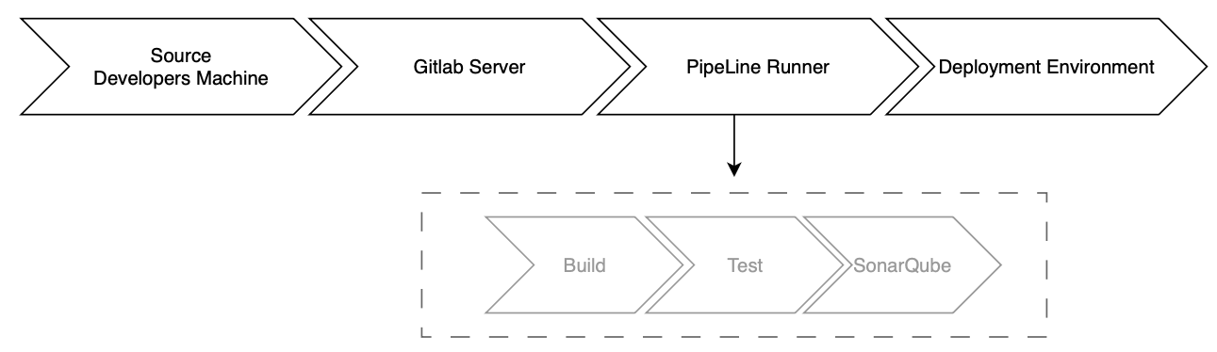

Explanation

Developers machine:
      - Code written and tested on local machine before changes being pushed to the GitLab Server.

GitLab Server:
      - The central repository where developer push his code changes. GitLab CI/CD pipelines are configured here to trigger on push to “main” event.

Pipeline Runner:
      - Fetches the code from the GitLab server, runs the defined stages (build, test, sonarqube-check, deploy), and manages the artifacts and dependencies.

Deployment Environment:
      - In the 'deploy' stage, the application is deployed to the target environment – container in the Docker.

Conclusion
  - The E-commerce Marketplace project embodies a comprehensive approach to developing a robust online platform for secure buying and selling of goods. Throughout the software architecture documentation, various design and technology decisions have been outlined to ensure the project's success.
  - Key technology decisions include leveraging Spring Boot for rapid development and dependency management, utilizing React for its component-based architecture and declarative syntax, integrating MySQL as a scalable and reliable relational database, and employing plain custom CSS for performance optimization and flexibility in UI design.
  - Furthermore, design decisions such as enforcing a "Single Role per User" policy in the backend underscore the project's commitment to simplicity, security, and scalability. Additionally, decisions like implementing a component-based architecture and RESTful API design emphasize modularity, maintainability, and responsiveness in the system's design.
  - By adhering to these decisions, the E-commerce Marketplace project aims to deliver a user-friendly, feature-rich, and scalable platform that meets the needs of both buyers and sellers. With a focus on technological innovation, security, and user experience, the project endeavors to establish itself as a leading player in the e-commerce domain.
  - As development progresses, continuous evaluation and adaptation of the architectural decisions will be crucial to ensure alignment with evolving project requirements and industry best practices. Through effective collaboration, diligent implementation, and rigorous testing, the E-commerce Marketplace project aspires to achieve its objectives and provide a seamless transaction experience for users worldwide.

